

What is ShareApp?

ShareApp is an API-based method to generate a GoodLeap credit application link from a form-page that you build and host that a borrower can complete independently via an email link sent or in browser. Ideal for sales reps, platform users, or self-service flows.
- All PII and Disclosures on GoodLeap servers
- Application details and loan status immediately available inside Origin and GoodLeap Pros

Full “Share App” API Documentation here: https://developer.goodleap.com/reference#tag/Loan-Share/paths/~1posfinancing~1rest~1v2~1loans-share/post

Request Body – Required Fields (next)

Field | Type | Description
offerId | string | ID of the loan offer the borrower will apply for.
state | string | Two-letter state abbreviation (e.g. "CA").
amount | object | Loan amount object, must include type: "USD" and value (loan amount).
applicant | object | At a minimum: firstName, lastName, and email.
sendEmail | boolean | Whether to send the ShareApp link to the applicant via email.

Basic Integration Path (Step-by-Step)

1. Get an Offer ID
You’ll need an offerId to generate a ShareApp link. This represents the loan program available to the customer. (Meaning GoodLeap Business Development division (BD) builds a pricing channel in Origin, allowing you to control which Loan Products are offered by installer/client. “The top 3”)

- Endpoint: GET /rest/v2/offers
- Filters: Use categoryId, state, or channel to narrow offers

2. Create a ShareApp Link
- Endpoint: POST /rest/v2/loans-share
- Purpose: Generates the URL that your customer will use.
- Pre-fills OfferID and Amount
- Customer fills out the rest of the application
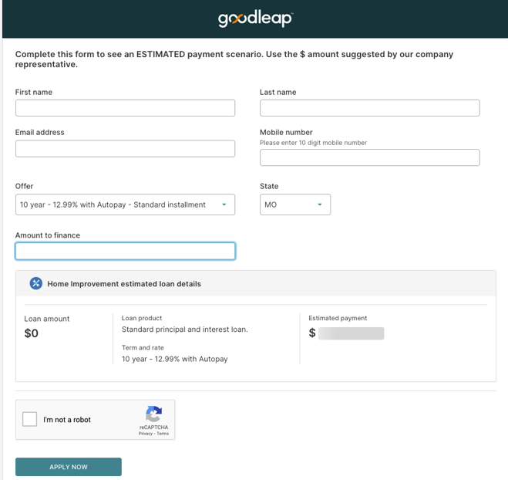
  - Payload sample:
{
"offerId": "your-offer-id-here",
"state": "CA",
"amount": {
"type": "USD",
"value": 20000
},
"applicant": {
"firstName": "John",
"lastName": "Doe",
"email": "john.doe@example.com"
},
"sendEmail": true,
"channel": Good
"referenceNumber": "INTERNAL_REF_123",
"decisionPageOptions": {
"redirectUrl": "https://yourplatform.com/thank-you"
}
}
- Response:
{
"link": "https://apply.goodleap.com/.../app-link",
"recipientEmail": "john.doe@example.com"
}
- redirectUrl sends the customer back to your site after submission and decision.

3. Monitor or Pull Loan Status

You can track loans submitted through ShareApp using:
- GET /loans?referenceNumber=INTERNAL_REF_123
- GET /loans/{id}
This allows you to build post-submission workflows or pull status for display in your platform.

Developer Tips
- You must use your APIkeys with basic authentication to call the APIs.
- Use the referenceNumber field to link the application to your CRM or internal systems.
Business Value
- Frictionless Borrower Experience: Customers complete applications at their convenience
- Fast set-up and Deployment
- Scalable & Fully Supported

